📘 ARCHITECTURE / WORKFLOW DIAGRAM DOCUMENT

Project: Checkout Flow A/B Testing Simulation
Dataset: sessions_with_segments_fixed.parquet

1. Purpose of the Architecture Diagram
This diagram illustrates the complete analytical workflow used in the A/B testing project, from raw data ingestion to statistical analysis and business insights.
It highlights:
- Data transformation layers
- Experiment logic
- Statistical analysis pipeline
- Output artifacts

2. High-Level Architecture Overview
The project follows a layered analytics architecture, commonly used in product analytics systems:
- Raw Event Layer
- Processed / Modeled Data Layer
- Experimentation Layer
- Analytics & Statistics Layer
- Reporting & Decision Layer

3. Architecture Components
Layer 1: Raw Data Layer
- Source: Multi-category e-commerce event logs
- Format: CSV
- Contents:
  - User interactions (views, cart, purchase)
  - Timestamps
  - Product and category metadata
Note: Raw data is large and stored externally. For this project, it is converted into Parquet format and removed after processing due to storage constraints.

Layer 2: Data Processing & Modeling
- Tools: Python (Pandas)
- Key operations:
  - Chunk-based reading of raw data
  - Conversion to Parquet parts
  - Sessionization (grouping events into sessions)
  - Aggregation to session-level metrics
  - Feature engineering (price bands, duration buckets)
Output:
- cleaned_sessions.parquet
- sessions_with_segments_fixed.parquet

Layer 3: Experimentation Layer
- Deterministic A/B assignment using hashing
- Variant assignment:
  - Variant A → Control checkout flow
  - Variant B → Redesigned checkout flow
- Simulation of checkout completion (completed_sim)
- Validation via Sample Ratio Mismatch (SRM) checks

Layer 4: Analytics & Statistical Layer
- Primary analyses:
  - Conversion rate comparison
  - Uplift calculation
  - Confidence intervals
  - Effect size estimation
- Statistical tests:
  - Z-test for proportions
  - Power & sample size calculation
  - Logistic regression for covariate adjustment
- Segmentation analyses:
  - Category-level
  - Price-band-level
  - Session-duration-level
  - New vs returning users

Layer 5: Reporting & Insights
- Visualization:
  - Conversion comparison plots
  - Funnel charts
  - Segment uplift charts
- Business metrics:
  - Revenue per session
  - Revenue per user
  - Guardrail monitoring
- Final outputs:
  - PDF report
  - Documentation (EDD, Data Dictionary, Metrics)
  - GitHub-ready artifacts

4. Architecture Diagram Flow
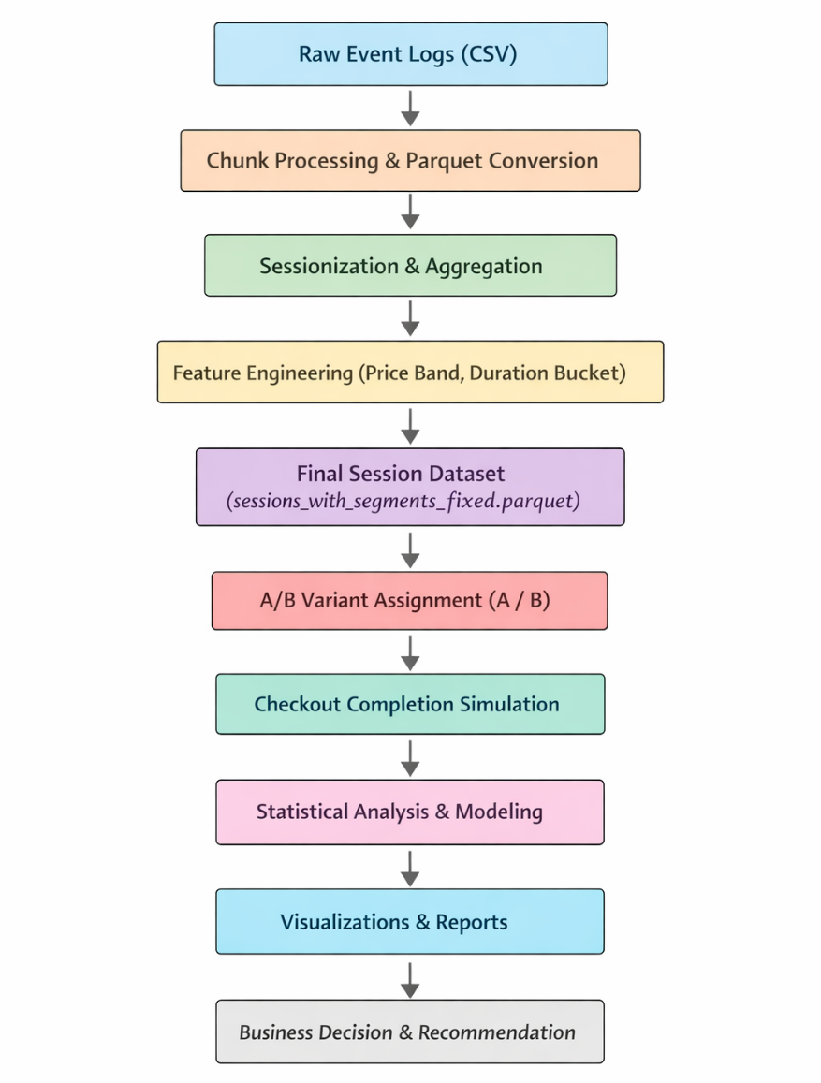
5. Tools Used at Each Stage
Stage | Tools
Data Ingestion | Python, Pandas
Data Storage | Parquet
Processing | Google Colab
Experimentation | Python
Statistics | SciPy, Statsmodels
Visualization | Matplotlib / Plotly
Documentation | Word / Google Docs
Publishing | GitHub

6. Why This Architecture Is Scalable
- Separation of raw and processed data
- Session-level modelling for efficient analysis
- Deterministic experimentation logic
- Modular analysis pipeline
- Reproducible and auditable workflow

